44.21: Conservation of lepton number.
a)
so lepton numbers are not conserved.
b) 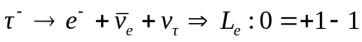
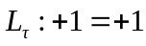
so lepton numbers are conserved.

c) 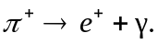 Lepton numbers are not conserved since just one lepton is
produced from zero original leptons.

d) 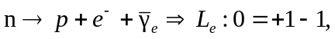 so the lepton numbers are conserved.

